abs return the absolute value of the given number. In other words, if the number is zero or positive then it is returned as-is, but if it is negative then it is multiplied by -1 to make it positive before returning it.

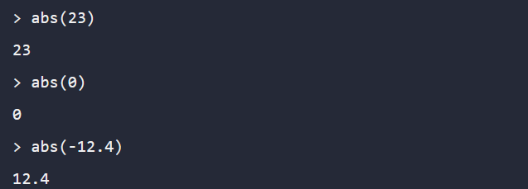

ceil returns the closest whole number that is greater than or equal to the given value, which may be a fraction.

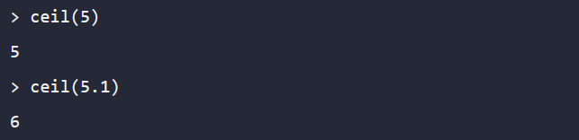

floor returns the closest whole number that is less than or equal to the given value, which may be a fraction.

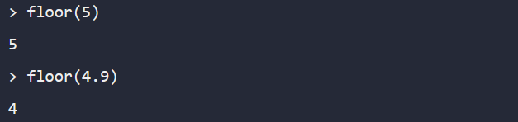

max takes one or more numbers and returns the greatest number from the set.



min takes one or more numbers and returns the smallest number from the set.

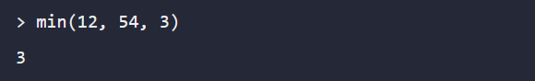

pow calculates an exponent, by raising its first argument to the power of the second argument.

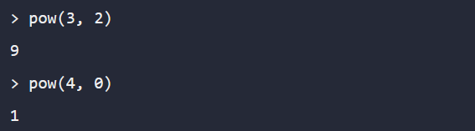

signum determines the sign of a number, returning a number between -1 and 1 to represent the sign.

